**Chapter 4**

**System Description**

**4.1 Modules of Blood Bank Management System**

Online Blood Bank management system is to provide services for the people who are in need of blood by getting help from the donors who are interested in donating blood for the people. There are seven main modules in this system.

1. Admin
2. Donors
3. Donor Registration
4. Modifying Donor Information
5. Receivers
6. Donor Search
7. Life Saving Contacts

4.1.1 Admin

Admin can manage donors, bank & receivers. He can add or remove any user and bank from the system. After filling the details by the bank, details will be verified by the admin and then and then only the user id and password will be provided to the respected bank.

· Change Password

· Modify donor/bank details

· delete donor/bank details

· Logout

Whenever a user wants to change his / her password he can select the change password option. The system displays the form, which asks him for his old password and new password. The system then compares the old password with the existing password in the database and if they match then the password is set to the new password in the database.

4.1.2 Donors

From this module user can create their account, when user create his account the user create a user id and password, which identifies him uniquely. From this module user can search donor for blood and can also refer his friend to become a donor. Donor can also get information like when he donated blood or when he will be able to donate blood.

4.1.3 Donor Registration

In this module, people who are interested in donating blood get registered in my site and give his overall details related to him, i.e. he fills in a registration form by giving the total details such as name, address, city, gender, dob, blood group, telephone numbers, e-mail address, etc. He was also given two fields’ username and password to fill such that he was a registered donor and he can enter the login form with his username and password and can modify his details if needed.

4.1.4 Modifying Donor Information:

The registered donor only is able to modify his details; no other person can modify his details as there was a login form which restricts others from entering the username and password providing high security for the details given by the donor. If at all the donor wants to modify his details, he was forced to give his username and password to enter in. After giving the username and password it checks for the donor whether he is an existing donor or not and if the username and password matches, he can then able to modify his total details. If the username and password do not exist then he gets a message as ‘Wrong ID and Password Entered, Try Again’.

**Following links are available on donor module.**

* Home
* Update Profile
* View Donation
* People in need
* Change Password
* Logout
* Search

4.1.5 Receivers

This module helps user to find blood group. When user click on find a blood group or search option system ask him to enter blood group, state, city, taluka in which who want search. After entering the blood group, system search for the availability of the blood group and give him the list of the donors who has the same blood group.

4.1.6 Donor Search:

The people who are in need of blood can search in our site for getting the details of donors having the same blood group and within the same city. They can directly click on the link search a donor and can select a city name as well as the blood group which he needs. He then gets the details of the donors who exist within the city and the same blood group that he has selected. If no match was are found for the city and group selected by him he gets a message ‘SORRY DONORS ARE NOT AVAILABE WITH THE FOLLOWING BLOOD GROUP AND AREA’.

4.1.7 Life Saving Contacts:

If at all the people in search of a donor doesn’t get any match for their area and group then they will be provided a service i.e. he will be given a Contact Person details for their nearby cities who have the details of many other donors with him. The people in search can call him and can get the details of the donors and can be provided services in this manner. But this life saving contact persons can be available only for a limited number of cities but not for all. These contact persons are the authorized persons of my blood bank.

**4.2 Pseudo code for Blood Bank Management System**

4.2.1 Client (Search module)

</script>

<Script src="https://ajax.googleapis.com/ajax/libs/jquery/1.12.0/jquery.min.js"></script> <!----This link is important for dependent drop drop----------------->

<form method="post" enctype="multipart/form-data" id="registrationForm" action="find.php">

<table class=" table table-bordered table-responsive" style="color:#000">

<tr><td>Blood Group</td><td><select name="blood_group" class="form-control" id="fetchval">

<option>-------Select Bloodgroup-------</option>

<?php

$q="select * from bloodgroup";

$r=mysqli_query($con,$q);

while($row=mysqli_fetch_array($r))

{

?>

<option value="<?php echo $row['bloodgroupname'] ?>"><?php echo $row['bloodgroupname'] ?></option>

<?php

}

?></select>

</td></tr>

<tr>

<td>State</td>

<td>

<select class=" c form-control validate[required] " name="state" id="state">

<option value="" selected="selected">--Select state--</option>

<?php

require 'config.php';

$sql="select DISTINCT state from statecity";

$result=mysqli_query($con,$sql) or die(mysqli_error());

while($row=mysqli_fetch_array($result))

{?>

<option value="<?php echo $row['state'];?>"><?php echo $row['state'];?></option>

<?php }

?>

</select>

</td>

</tr>

<tr>

<td>District</td>

<td>

<select class="form-control validate[required]" id="district" name="district">

<option value="" selected="selected">--Select District--</option>

</select>

</td>

</tr>

<tr>

<td>Taluka</td>

<td>

<select class="form-control validate[required]" name="city" size="1"

id="city">

<option value="" selected="selected" >--Taluka--</option>

</select>

</td>

</tr>

<tr><td colspan="2" align="center"><input type="submit" name="save" value="Search" class="btn btn-success"> &nbsp;&nbsp;&nbsp;<input type="reset" name="reset" value="Clear" class="btn btn-danger"></td></tr>

</table>

</form>

</div>

</div>

<?php /*?> <?php

if(isset($_POST['save']))

{

$query="select * from donor_registration where blood_group='".$_POST['blood_group']."'and state='".$_POST['state']."'and district='".$_POST['district']."'and city='".$_POST['city']."'";

$res=mysqli_query($con,$query) or die(mysqli_error($con));

if(mysqli_num_rows($res)>0)

{

?>

<table class="table table-bordered">

<tr>

<th>Name</th>

<th>Gender</th>

<th>Age</th>

<th>Mobile No.</th>

<th>Blood Group</th>

<th>Email</th>

<th>Image</th>

</tr>

<?php

while($row=mysqli_fetch_array($res))

{

?>

<tr>

<td><?php echo $row['donor_name'] ?></td>

<td><?php echo $row['gender'] ?></td>

<td><?php echo $row['age'] ?></td>

<td><?php echo $row['mobile_no'] ?></td>

<td><?php echo $row['blood_group'] ?></td>

<td><?php echo $row['email'] ?></td>

<td><img src="../profile/<?php echo $row['img'] ?>" style="width:150px; height:100px"></td>

</tr>

<?php

}

}

else

{

echo "<script>";

echo "alert('Result Not Found');";

echo "</script>";

}

}

?>

</table><?php */?>

</div>

<div class="col-md-3 w3ls-about-top-left-grid"></div>

<div class="clearfix"> </div>

</div>

</div>

**Chapter 5**

**Modeling and Designing**

**5.1 System Flow Diagram**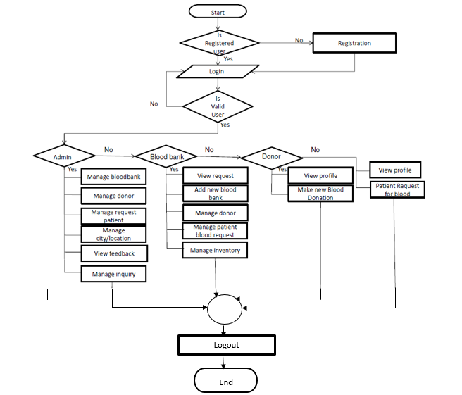

Fig.5.1.1: System Flow

**5.2 ER Diagram**

An entity relationship model, also called an ER diagram, is a graphical representation of entities and their relationships to each other, typically used in computing in regard to the organization of data within database or information system.

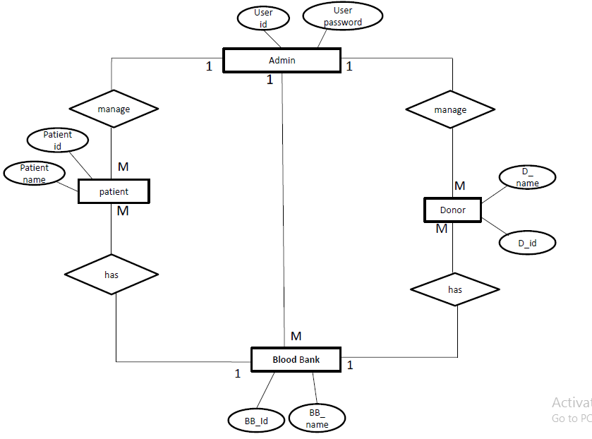

Fig.5.2.1: ER Diagram

**5.3 Data Flow Diagram**

A data flow diagram (DFD) is a graphical representation of “flow” of data through an information system, modeling its process aspects. A DFD is often used as a preliminary step to create an overview of system, which can later be elaborated. DFD can also used for the visualization of data processing.

5.3.1 DFD level-I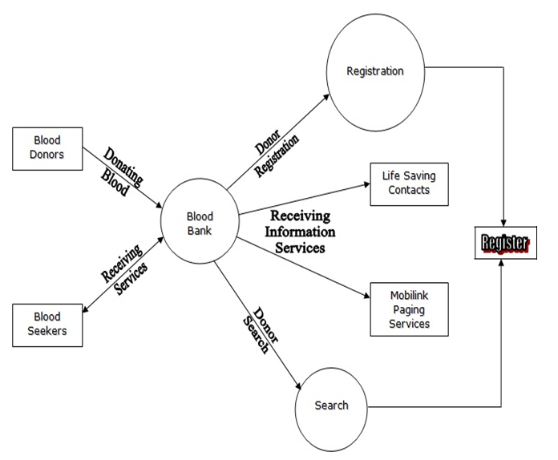

Fig.5.3.1.1: DFD Level-I

5.3.2 DFD level-II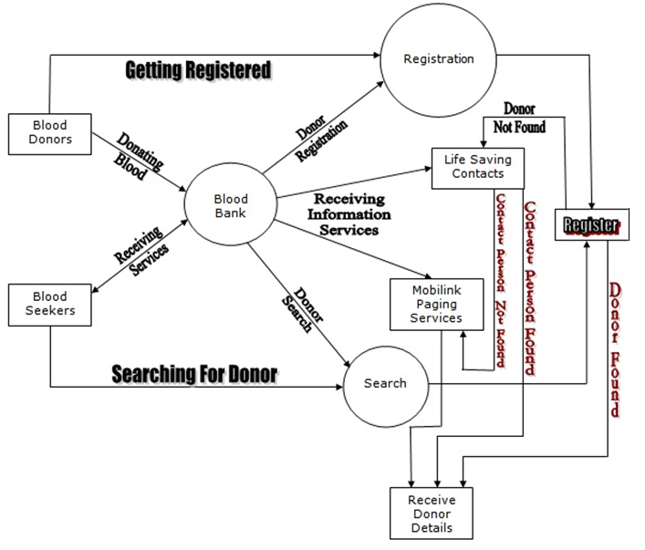

Fig.5.3.2.1: DFD Level-II

**5.4 UML Diagrams**

UML stands for Unified Modeling Language. The approach used by UML is called as object oriented approach for the development of models.

UML is used in converting reality with the help of simplest models. The major contributors to UML are of James Rumbaugh Ivar Jacobson and Grady Booch and the Rational Software Corporation.

Because of great contribution of the people and organization above, UML is accepted as a standard modeling language by OMG.

The UML modeling consist of following diagrams to model a software system and those diagrams are:

1. Object Diagram
2. Class Diagram
3. Use-Case Diagram
4. Sequence Diagram
5. Activity Diagram
6. Collaboration Diagram
7. Deployment Diagram

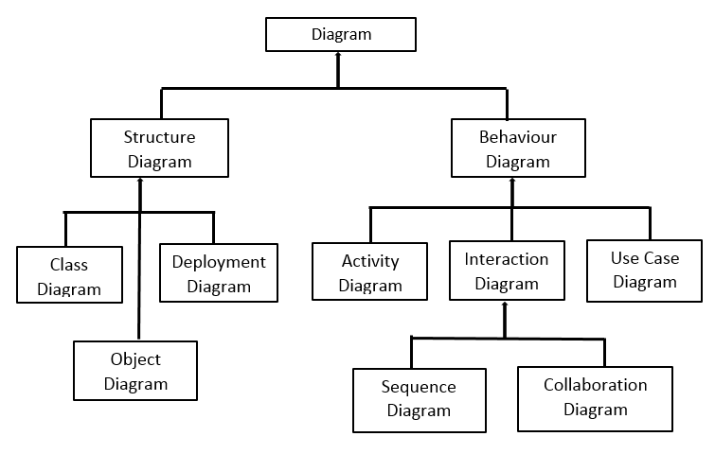

Fig.5.4.1: Classification of UML

5.4.1 Class Diagram

In [software engineering](https://en.wikipedia.org/wiki/Software_engineering), a class diagram in the [Unified Modeling Language](https://en.wikipedia.org/wiki/Unified_Modeling_Language) (UML) is a type of static structure diagram that describes the structure of a system by showing the system's [classes](https://en.wikipedia.org/wiki/Class_(computer_science)), their attributes, operations (or methods), and the relationships among objects. The class diagram is a static diagram. It represents the static view of an application. The class diagrams are widely used in the modelling of object oriented systems because they are the only UML diagrams which can be mapped directly with object oriented languages.

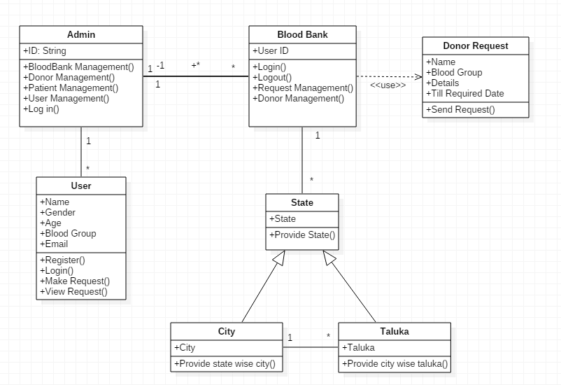

Fig.5.4.1.1: Class Diagram

5.4.2 Use-case Diagram

**Use case diagrams** are usually referred to as [behavior diagrams](http://www.uml-diagrams.org/uml-25-diagrams.html#behavior-diagram) used to describe a set of actions ([use cases](http://www.uml-diagrams.org/use-case.html)) that some system or systems ([subject](http://www.uml-diagrams.org/use-case-subject.html)) should or can perform in collaboration with one or more **external users** of the system ([actors](http://www.uml-diagrams.org/use-case-actor.html)). A use case diagram at its simplest is a representation of a user's interaction with the system that shows the relationship between the user and the different [use cases](https://en.wikipedia.org/wiki/Use_case) in which the user is involved.

5.4.2.1 Admin

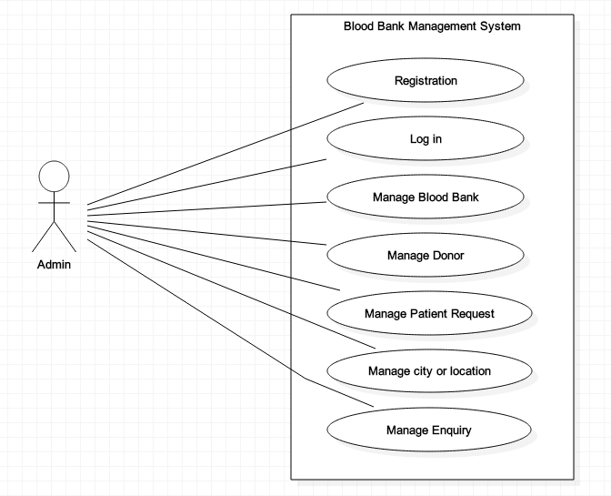

Fig.5.4.2.1.1: Use-Case Diagram for Admin

5.4.2.2 Blood Bank

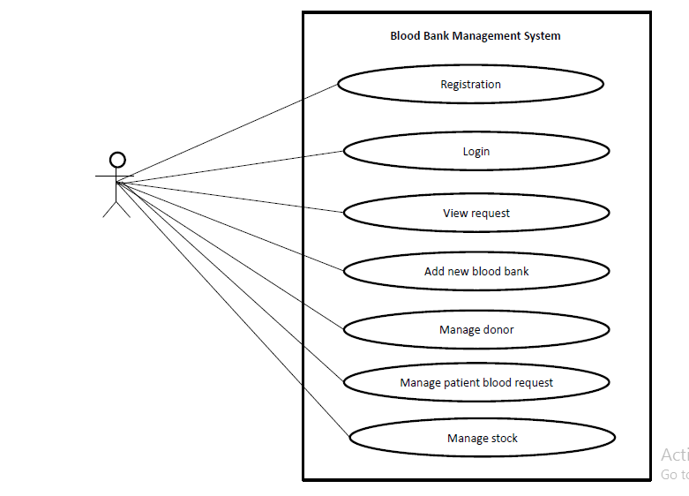

Fig.5.4.2.2.1: Use-Case Diagram for Blood Bank

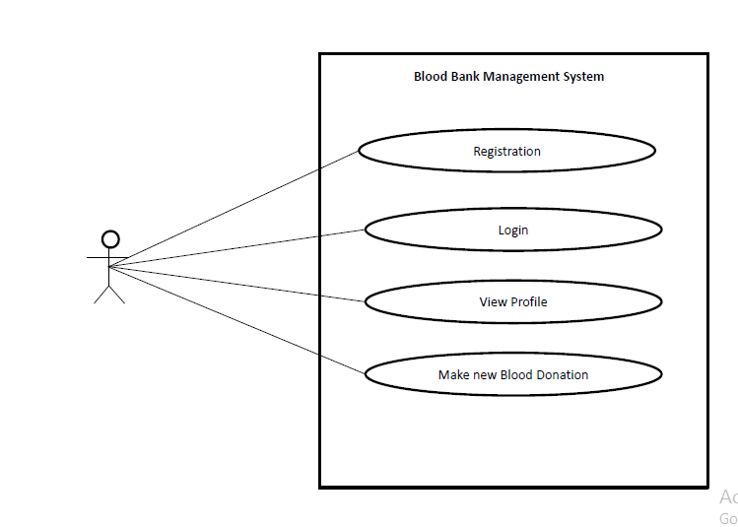5.4.2.3 Donor

Fig.5.4.2.3.1: Use-Case Diagram for Donor

5.4.2.4 Patient

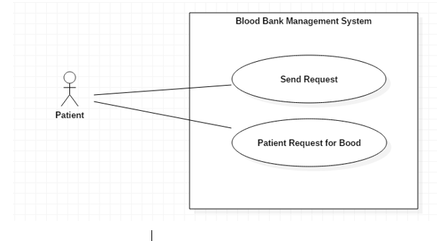

Fig.5.4.2.4.1: Use-Case Diagram for Patient

5.4.3 Sequence Diagram

A sequence diagram is an [interaction diagram](https://en.wikipedia.org/wiki/Interaction_diagram) that shows how objects operate with one another and in what order. It is a construct of a [message sequence chart](https://en.wikipedia.org/wiki/Message_sequence_chart). A sequence diagram shows object interactions arranged in time sequence. It depicts the objects and classes involved in the scenario and the sequence of messages exchanged between the objects needed to carry out the functionality of the scenario.

5.4.3.1 Admin

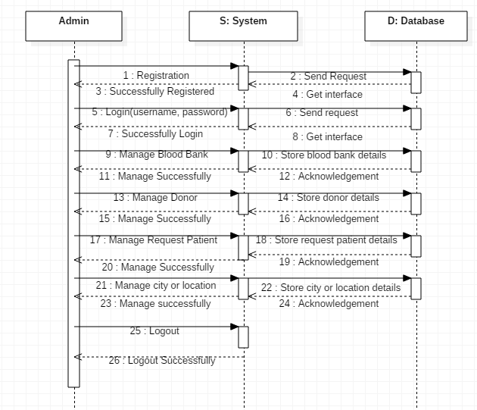

Fig.5.4.3.1.1: Sequence Diagram for Admin

5.4.3.2 Blood Bank

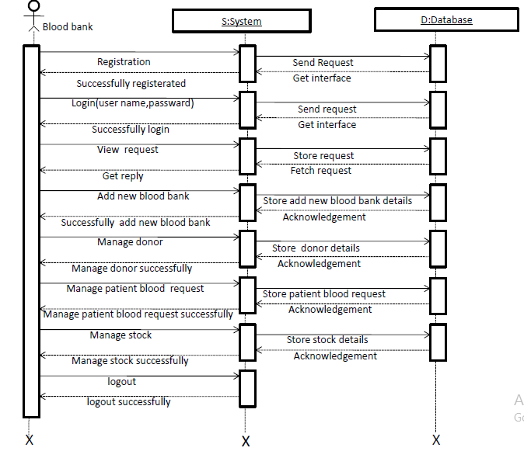

Fig.5.4.3.2.1: Sequence Diagram for Blood Bank

5.4.3.3 Donor

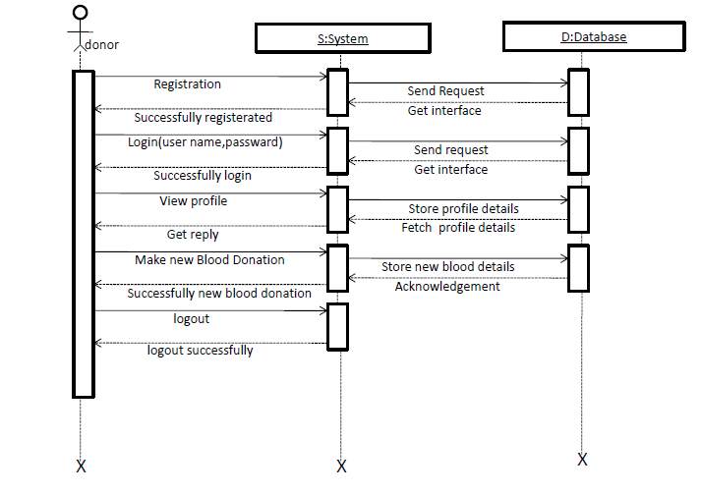

Fig.5.4.3.3.1: Sequence Diagram for Donor

5.4.3.4 Patient

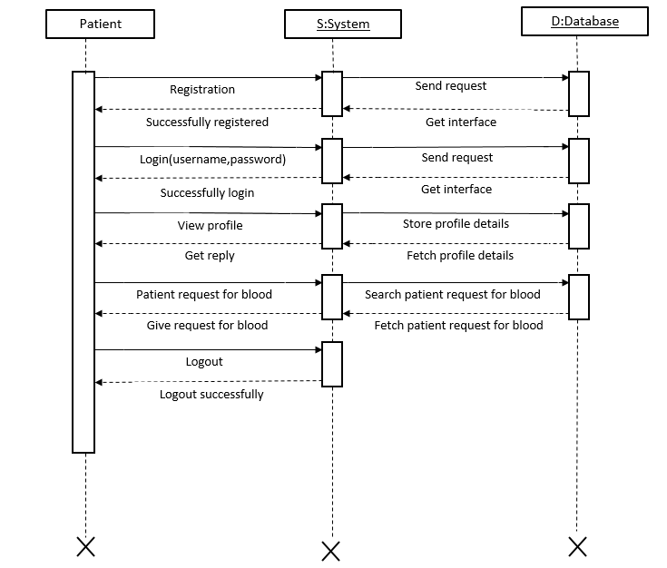

Fig.5.4.3.4.1: Sequence Diagram for Patient

5.4.4 Activity Diagram

Activity diagram is another important diagram in UML to describe dynamic aspects of the system. Activity diagram is basically a flow chart to represent the flow from one activity to another activity. The activity can be described as an operation of the system. So the control flow is drawn from one operation to another. This flow can be sequential, branched or concurrent. Activity diagrams deals with all type of flow control by using different elements like fork, join etc.

5.4.4.1 Admin

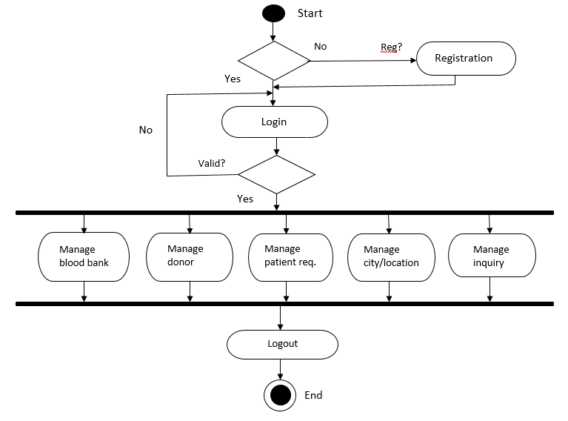

Fig.5.4.4.1.1: Activity Diagram for Admin

5.4.4.2 Blood Bank

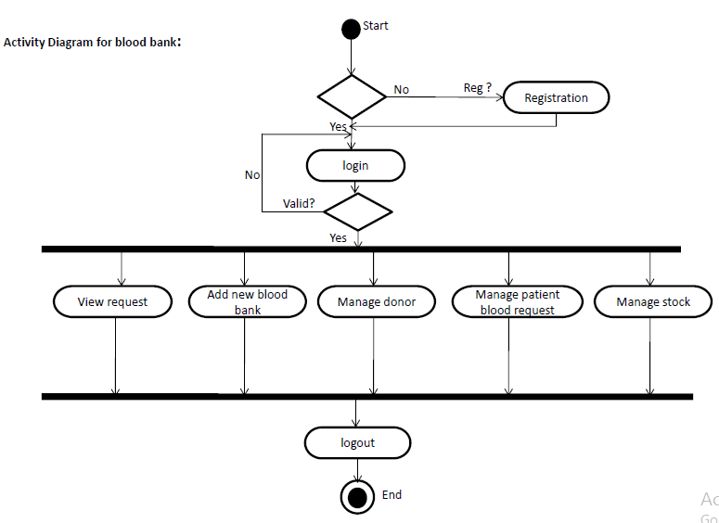

Fig.5.4.4.2.1: Activity Diagram for Blood Bank

5.4.4.3 Donor

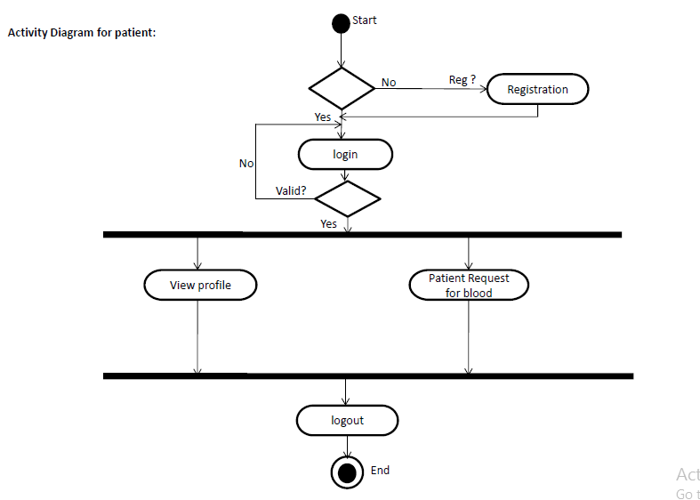

Fig.5.4.4.3.1: Activity Diagram for Donor

5.4.4.4 Patient

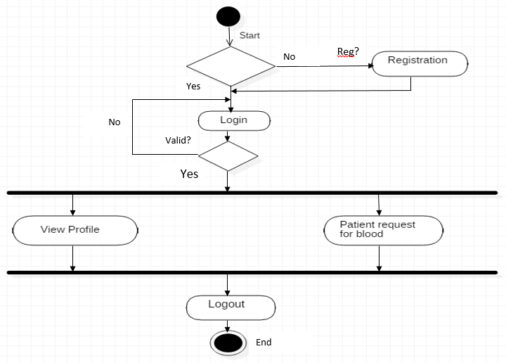

Fig.5.4.4.4.1: Activity Diagram for Patient

5.4.5 Collaboration Diagram

A collaboration diagram, also called a communication diagram or interaction diagram, is an illustration of the relationships and interactions among [software](http://searchsoa.techtarget.com/definition/software) [object](http://searchsoa.techtarget.com/definition/object)s in the Unified Modeling Language (UML). The second interaction diagram is collaboration diagram. It shows the object organization as shown below. Here in collaboration diagram the method call sequence is indicated by some numbering technique. The number indicates how the methods are called one after another. We have taken the same order management system to describe the collaboration diagram.

5.4.5.1 Admin

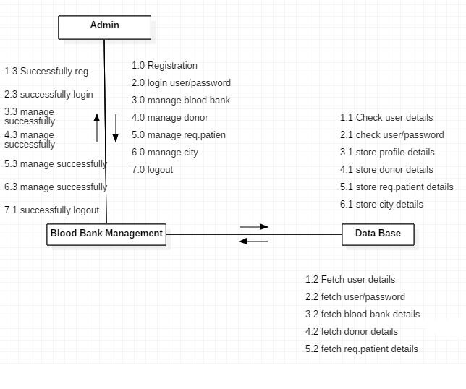

Fig.5.4.5.1.1: Collaboration Diagram for Admin

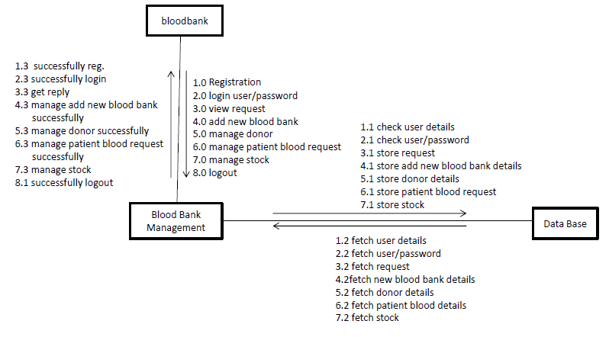5.4.5.2 Blood Bank

Fig.5.4.5.2.1: Collaboration Diagram for Blood Bank

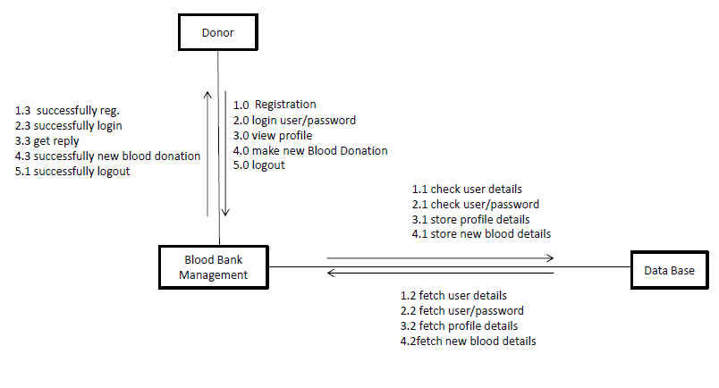5.4.5.3 Donor

Fig.5.4.5.3.1: Collaboration Diagram for Donor

5.4.5.4 Patient

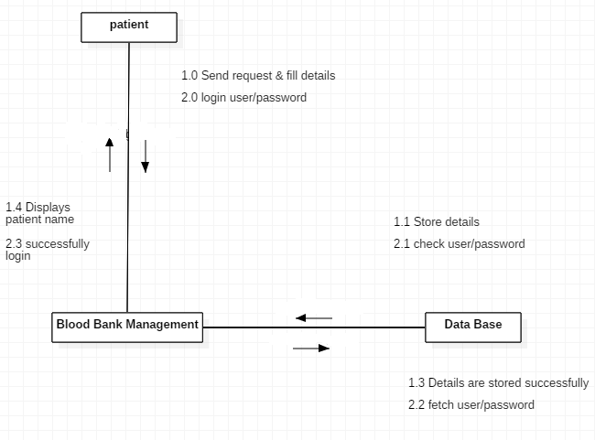

Fig.5.4.5.4.1: Collaboration Diagram for Patient

**Chapter 6**

**Testing**

**6.1 Donor Login**

Table 6.1.1 Donor Login Test Cases

|  |  |  |  |  |
| --- | --- | --- | --- | --- |
| Sr.no. | Test Case | Expected Result | Actual Result | Status |
| 1 | Whether clicking on submit button without user name and password it allows login or not. | System does not allow user to login. | System displays  message & resume  to the same page. | Pass |
| 2 | Whether click on submit button with invalid user name and or password it displays the message or not. | It should display message ‘Please fill up the username or password’ | It displays message | Pass |
| 3 | Whether by clicking on submit  button with correct  username and password. | System allow user to  login | System allow user to access application based on rights given to him. | Pass |

**6.2 Donor Registration**

Table 6.2.1 Donor Registration Test Cases

|  |  |  |  |  |
| --- | --- | --- | --- | --- |
| Sr.no. | Test Case | Expected Result | Actual Result | Status |
| 1 | Whether clicking on Donor Registration button with blank field it allows register or not. | System does not allow user to register | System displays  message & resume  to the same page. | Pass |
| 2 | Whether click on Clear button it removes all the fields or not. | It should clear all the fields | It resets | Pass |
| 3 | Whether by clicking on Donor Registration  button with all correct fields it register donor or not | System should register to database | System allow to register | Pass |

**6.3 Blood Bank**

Table 6.3.1 Blood Bank Test Cases

|  |  |  |  |  |
| --- | --- | --- | --- | --- |
| Sr.no. | Test Case | Expected Result | Actual Result | Status |
| 1 | Whether clicking on Login button it login to correct bank account | It should login to correct account | It Logins to correct account | Pass |
| 2 | After login, whether clicking on different menus, the specific pages gets open or not | It should open the specific page. | It opens the specific page. | Pass |
| 3 | In Update Profile menu, after filling the details whether clicking on Update Profile button it gets update or not. | It should update the information. | It updates the information. | Pass |
| 4 | Whether in settings menu, after clicking on change password button the password changes or not. | It should change the password. | It changes the password. | Pass |
| 5 | After Logout, whether clicking on back button it opens the previous page or not. | It should not open the previous page. | It doesn’t open the previous page. | Pass |

**6.4 Search (Donor Request)**

Table 6.4.1 Search (Donor Request) Test Cases

|  |  |  |  |  |
| --- | --- | --- | --- | --- |
| Sr.no. | Test Case | Expected Result | Actual Result | Status |
| 1 | Whether clicking on search menu it displays the search donor form or not | It should display the search donor form | It displays the search donor form | Pass |
| 2 | Whether clicking on dropdown button of blood group & state it shows the sub menus or not | It should show the sub menus of blood group | It shows the sub menus of blood group | Pass |
| 3 | Whether clicking on dropdown button of district it shows the sub menus of that specific selected state or not | It should show the sub menus of that specific selected state | It show the sub menus of that specific selected state | Pass |
| 4 | After clicking on clear button it resets the details or not. | It should resets the details | It resets the details | Pass |

**6.5 Admin**

Table 6.5.1 Admin Test Cases

|  |  |  |  |  |
| --- | --- | --- | --- | --- |
| Sr.no | Test Case | Expected Result | Actual Result | Pass |
| 1 | After verify the bank details from the Blood Group List it either approves or delete the bank | It should either approve or delete the bank after verify | It approves or delete the bank after verify | Pass |
| 2 | After adding new camp in Add Camp option, the camp displays at the client page or not | It should displays at the client page | It displays at the client page | Pass |

**6.6 Snapshots**

6.6.1 Snapshot of Search (Donor Request)

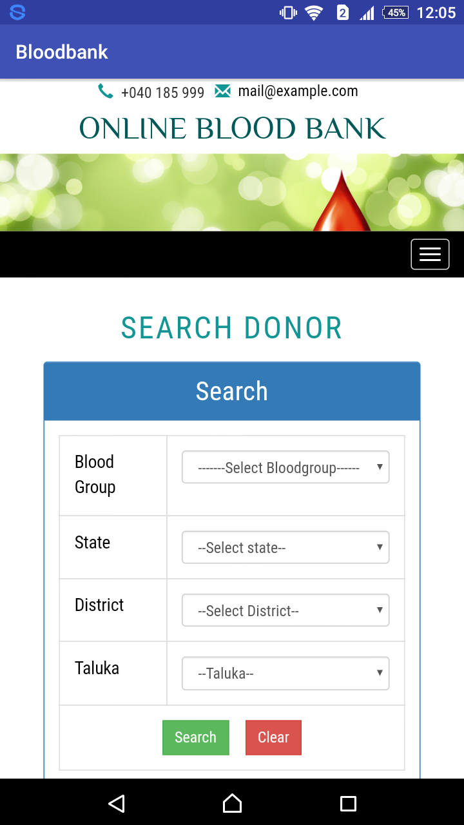

Fig.6.6.1.1: Snapshot of Search

6.6.2 Snapshot for Donor Registration

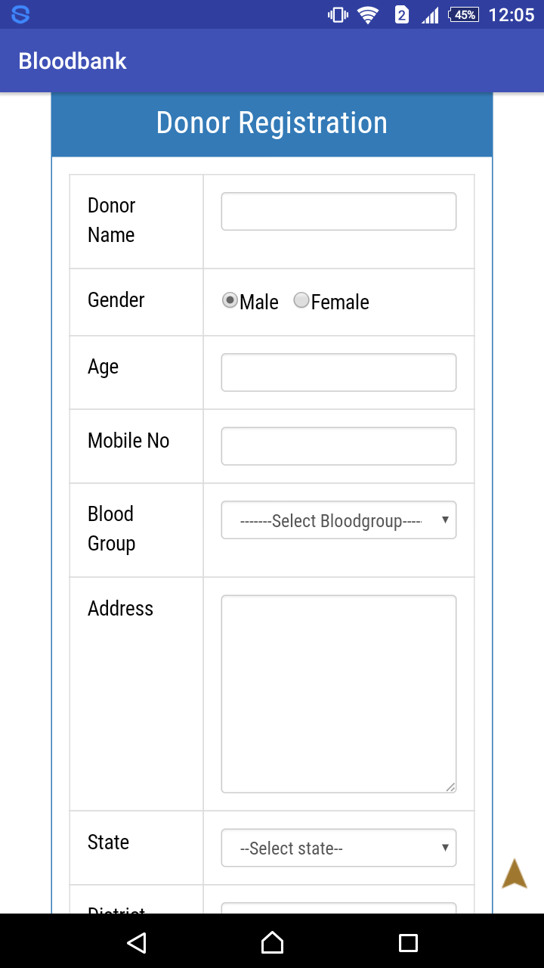

Fig.6.6.2.1: Snapshot of Donor Registration

6.6.3 Snapshot for Donor Login

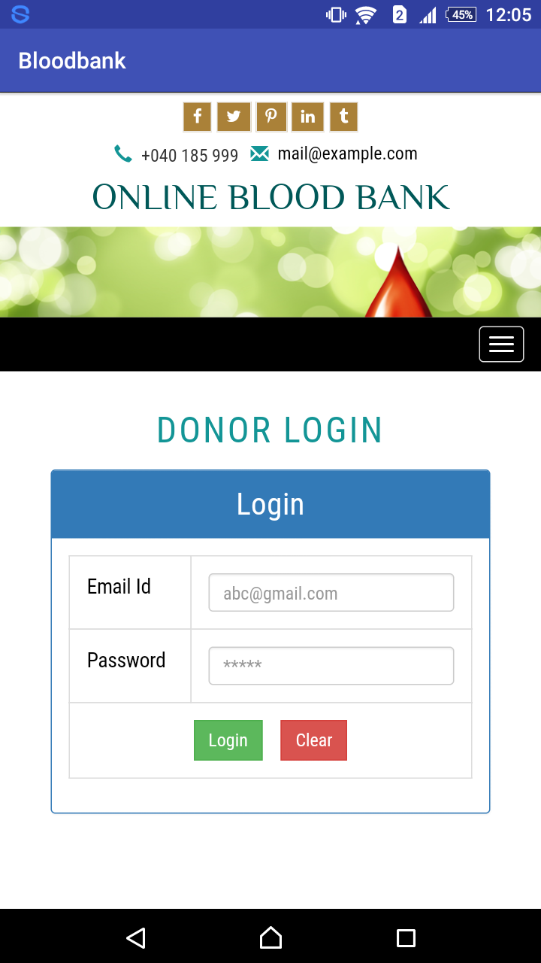

Fig.6.6.3.1: Snapshot of Donor Login

**Chapter 7**

**Conclusion and Future Scope**

**7.1 Future Scope**

* Through online directory user can search any blood bank data by location.
* User can also message module.
* User can see this website and search blood bank.

**7.2 Conclusion**

It has been a great pleasure for me to work on this exciting and challenging project. This project proved good for me as it provided practical knowledge of not only programming in PHP web based application and no some extent Windows Application and SQL Server, but also about all handling procedure related with **“Blood Bequeath Federal”.** It also provides knowledge about the latest technology used in developing web enabled application and client server technology that will be great demand in future. This will provide better opportunities and guidance in future in developing projects independently.

**Result**

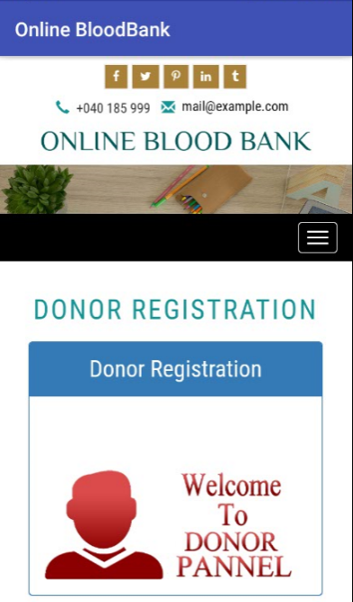Result includes the information about how the operation executes and displays the result by giving various inputs.

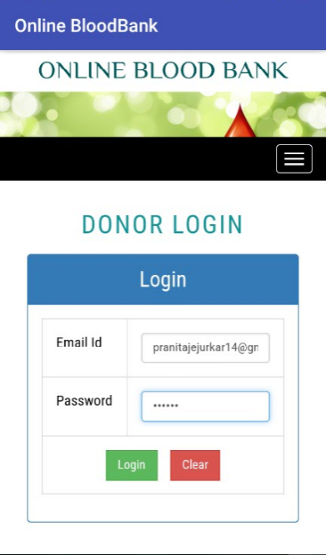

Fig. Screenshot of Donor Login Fig. Screenshot after login

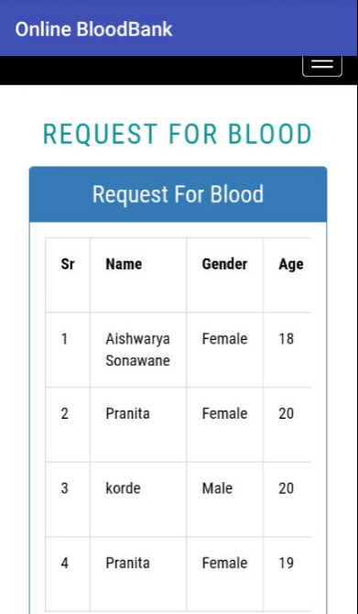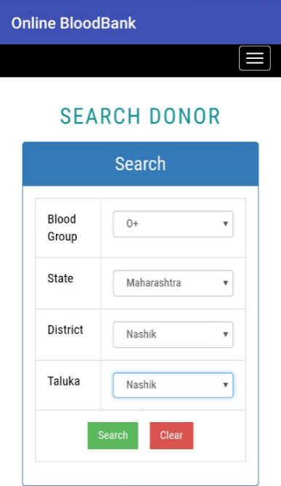

Fig. Screenshot of search option Fig. Screenshot after searching

REFERENCES

1. Gordon, Murray B. (1940). "Effect of External Temperature on Sedimentation Rate of Red Blood Corpuscles". Journal of the American Medical Association. **114** (16). [doi](https://en.wikipedia.org/wiki/Digital_object_identifier):[10.1001/jama.1940.02810160078030](https://dx.doi.org/10.1001%2Fjama.1940.02810160078030).
2. Kim Pelis (2001). ["Taking Credit: The Canadian Army Medical Corps and the British Conversion to Blood Transfusion in WWI"](https://muse.jhu.edu/journals/journal_of_the_history_of_medicine_and_allied_sciences/v056/56.3pelis.html). Journal of the History of Medicine and Allied Sciences. **56**: 238–77. [doi](https://en.wikipedia.org/wiki/Digital_object_identifier):[10.1093/jhmas/56.3.238](https://dx.doi.org/10.1093%2Fjhmas%2F56.3.238). [PMID](https://en.wikipedia.org/wiki/PubMed_Identifier) [11552401](https://www.ncbi.nlm.nih.gov/pubmed/11552401).
3. ["Red Gold: the Epic Story of Blood"](http://www.pbs.org/wnet/redgold/history/timeline3.html). PBS.
4. Susan Macqueen; Elizabeth Bruce; Faith Gibson (2012). [The Great Ormond Street Hospital Manual of Children's Nursing Practices](http://books.google.co.uk/books?id=n0_Vqz-V_T8C). John Wiley & Sons. p. 75.
5. ["Percy Oliver"](http://www.pbs.org/wnet/redgold/innovators/bio_oliver.html). Red Gold: The Eipc Story of Blood.
6. Christopher D. Hillyer (2007). [Blood Banking and Transfusion Medicine: Basic Principles & Practice](http://books.google.co.uk/books?id=3QwXx_enKbcC). Elsevier Health Sciences.
7. Morris Fishbein, M.D., ed. (1976). "Blood Banks". The New Illustrated Medical and Health Encyclopedia. **1** (Home Library ed.). New York, N.Y. 10016: H. S. Stuttman Co. p. 220.
8. Kilduffe R, DeBakey M (1942). The blood bank and the technique and therapeutics of transfusion. St. Louis: The C.V.Mosby Company. pp. 196–97.
9. Starr, D (1998). Blood: An Epic History of Medicine and Commerce. Little, Brown and company. pp. 84–87. [ISBN](https://en.wikipedia.org/wiki/International_Standard_Book_Number) [0 316 91146 1](https://en.wikipedia.org/wiki/Special:BookSources/0_316_91146_1).
10. ["The History of Blood Ttansfusion"](http://onlinelibrary.wiley.com/doi/10.1046/j.1365-2141.2000.02139.x/pdf). British Journal of Haematology. **110**: 758–67. 2001. [doi](https://en.wikipedia.org/wiki/Digital_object_identifier):[10.1046/j.1365-2141.2000.02139.x](https://dx.doi.org/10.1046%2Fj.1365-2141.2000.02139.x). [PMID](https://en.wikipedia.org/wiki/PubMed_Identifier) [11054057](https://www.ncbi.nlm.nih.gov/pubmed/11054057)